**A Visual Report with Python and QlikView: A case for a peatland (Lettosuo) from Finland**

**(An academic project done by)**

**Md Shamsuzzaman**

**Helsinki, Finland**

**26th January 2018**

Contents

Structure of this report 3

1 Visualization through Python 3

The graphical figures through Python are being present below with a brief introduction and result of analysis. 3

1.1 Background Study 3

1.2 Study Site and Experimental Design 3

1.3 Analysis 6

2 Visualization through QlikView 14

3 Conclusion 18

# Structure of this report

The Lettosuo dataset has been analyzed by Python and QlikView. In the first part, the outcomes through Python are being presented, and the second part of this report will present the QlikView´s outcomes.

# 1 Visualization through Python

The graphical figures through Python are being presented below with a brief introduction and the result of analysis.

## 1.1 Background Study

The study was carried out at Lettosuo which is an associated ecosystem site of Integrated Carbon Observation System (ICOS) located in Tammela area. Lettosuo is one of the drained peatlands of southern Finland which was drained in early 1970 for forestry. Mean annual temperature and precipitation is 4.6°C and 627 mm respectively.

## 1.2 Study Site and Experimental Design

This dataset is primary data which has been recorded by using Environmental Gas Measurement (EGM), water table measurement stick, soil thermometer. The data was collected once a week to measure 98 points and the measurement was to complete within the day by considering same environmental conditions. In 2017 (June to August), 8 weeks´ data (98*8) were recorded.

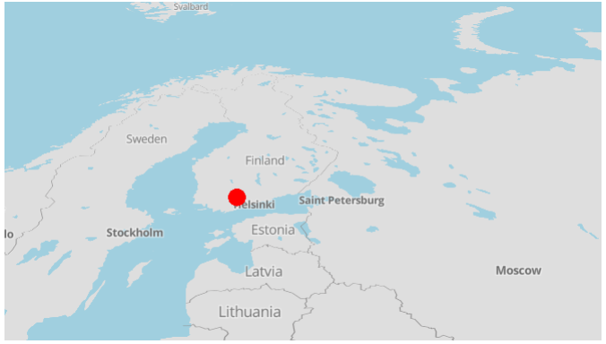

**Fig 1. Study site**

The study site, known as Lettosuo, is located in Tammela which is around 90 km away from the capital city (Helsinki) of Finland.

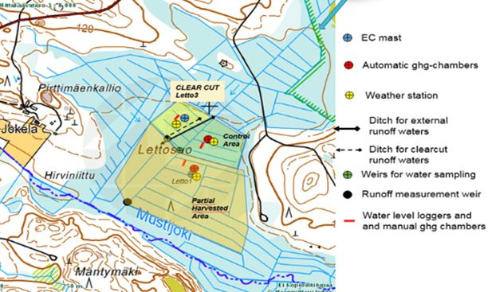

**Fig 2. Study sites (Partial Harvested, Control, and Clear cut area)**

Lettosuo has three sites within it which are known as control, harvested (partially), and clear cut. A brief of the features/factors which are being analyzed is following below:

**Plot_no:** Measurement place no

**Date:** Measurent day

**Hours:** Measurements time

**Mins:** Measurements time

**CO2:** Emission rate from per square meter area at each sec (gm/m2s)

**Soil_Tem:** Soil temperature (°C) at 5cm depth

**Water_L**: Water level (in cm) in soil from soil surface

**Direction:** Geographic position

**Distance:** Nearest ditch (canal for water passing) distance (in m)

**Site_Type:** Categories based on vegetation (plants)

**Peat_Moss%:** % of peat mosses in the plot

**Forest_moss%:** % of forest moss in the plot

**Litters%:** % of debris (dead plant part mostly leaves) in the plot

**Vegetation%**: % of plants in the plot

**Treatment:** Harvested – Trees have been logged (cut)

Control – Untouched (pristine)

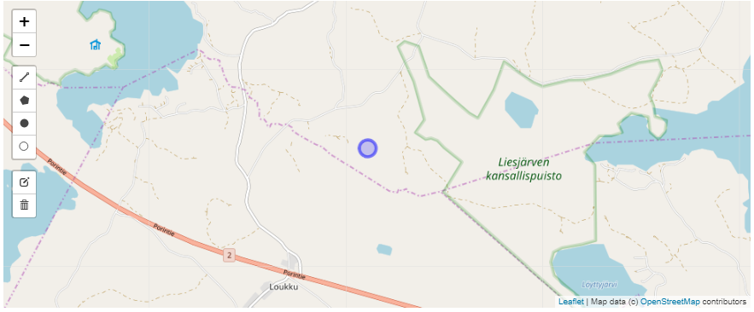

**Fig 3. An aerial view of the study site**

Figure 3 shows an aerial view of the study site. Here, it is being seen that the site is near some water bodies.

## 1.3 Analysis

The main objective of this study was to observe whether the environmental factors (soil temperature, water table, forest moss and litter) can be used to predict the CO2 emission of this drained peatland. At the very beginning, the data has been checked based on the normality. QQ plot have been used to check the linearity justification for these factors.

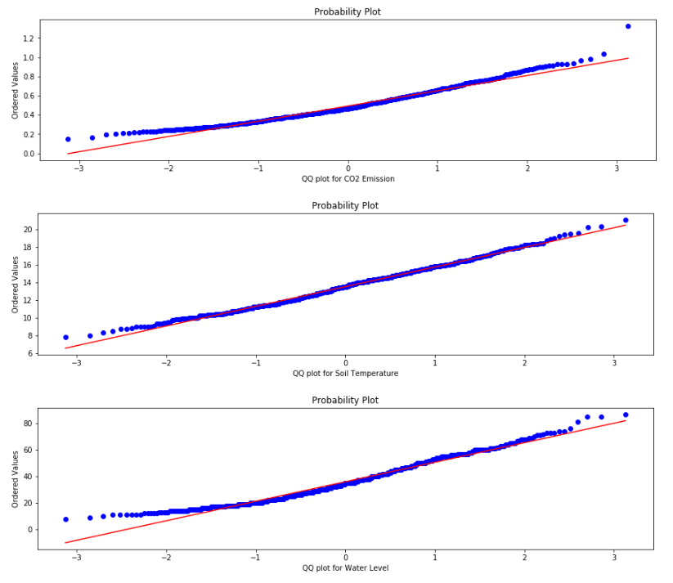

**Fig 4. QQ plot**

According to the Fig 4, QQ plots present the linearity of the CO2 emission, Water level, and Soil temperature data with a potential outlier for CO2 emission data.

## 

**Fig 5. Changes of CO2 emission with different factors**

From the aforementioned graphical presentation (Fig 5):

Direction wise CO2 emission distribution, it has been revealed that East direction (*E*) has highest level of CO2 emission among the ten directions while the South-South-West has the lowest. During the experiment, it has been found that CO2 emission increases with increase of Soil temperature, while Water level does not show any specific trend for CO2 emission.

Mtkg II site shows highest level of CO2 emission. Apart from that it also has been found that most of the plots are at a range of 4-20 meter distance from the nearest ditch with a comparative high emission level than the furthest one.

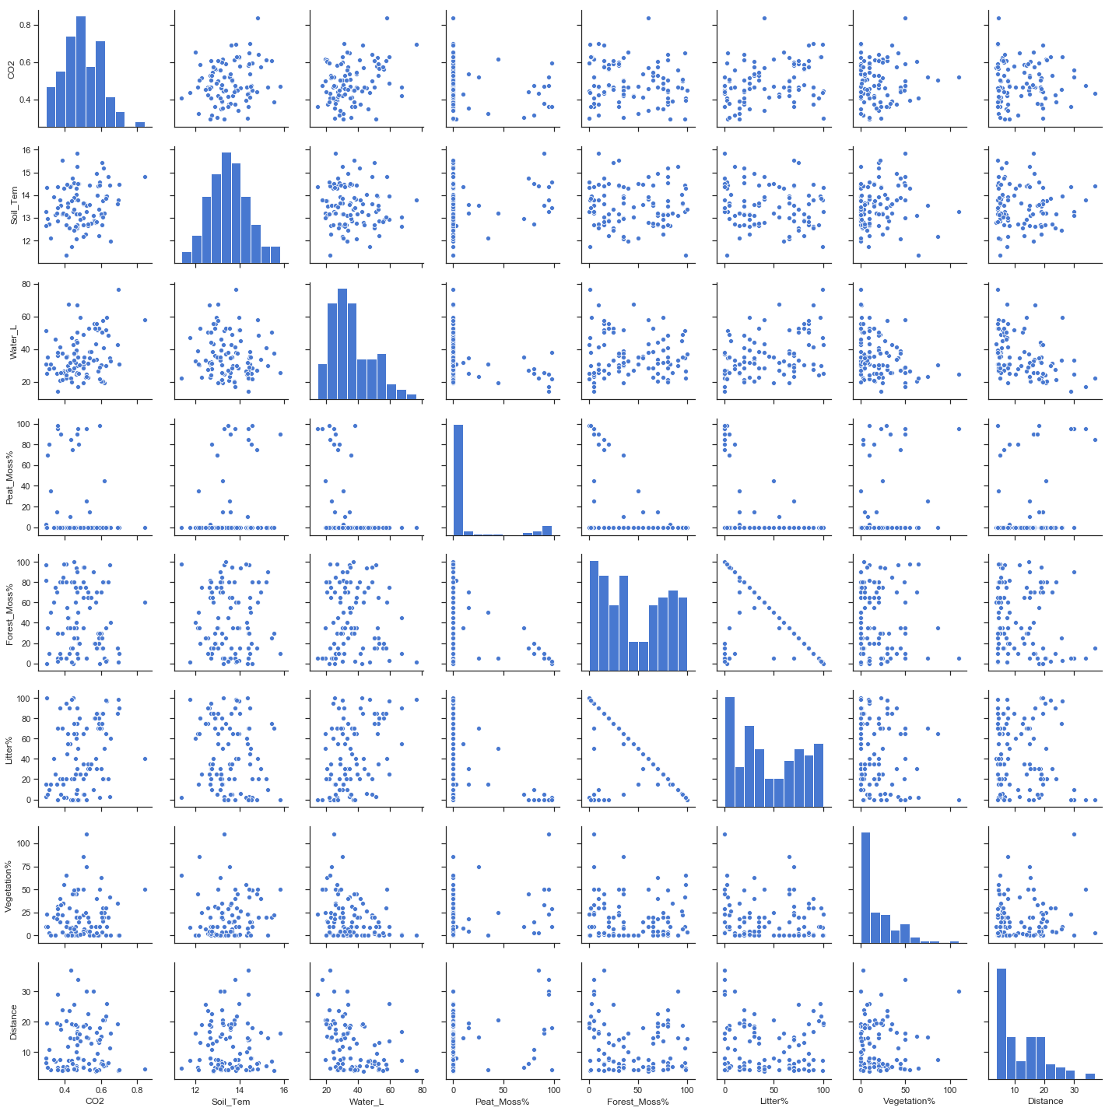

**Fig 6. Scatter plot matrix of the factors**

Scatter plot matrix (fig 6) is one of the most important visualization tools through which the linearity among the factors of a data set can be carried out. As it is shown in figure 6, the matrix shows linearity in soil temperature, water level, ditch distance, and field vegetation with soil CO2 emission.

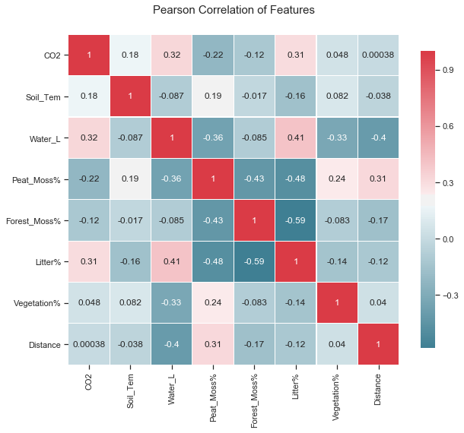

**Fig 8. Pearson correlation of matrix**

From the Pearson correlation matrix (fig 8), soil temperature, water level, litter, vegetation, and distance have a positive correlation with CO2 emission , but they do not show any strong relation (>= .50). However, on the other hand Peat moss and Forest moss keep a negative (weak) relationship.

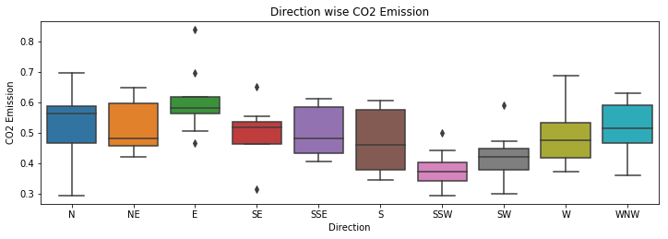

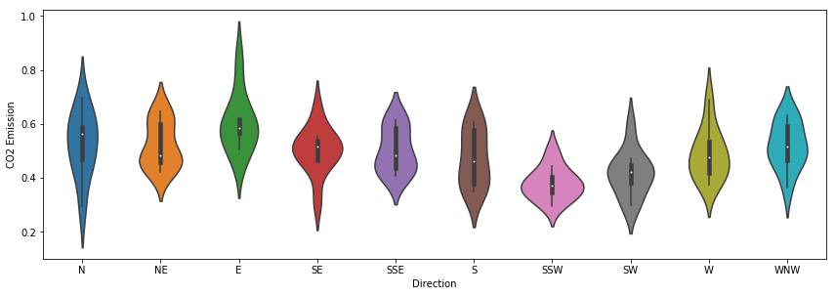

**Fig 9. Box plot and Violin plot representation of CO2 emission (direction wise)**

According to the Box and Violin plot (fig 9), the highest distribution of the CO2 is at East direction with a few potential outliers. Violin plot also show a probability density of CO2 at each direction.

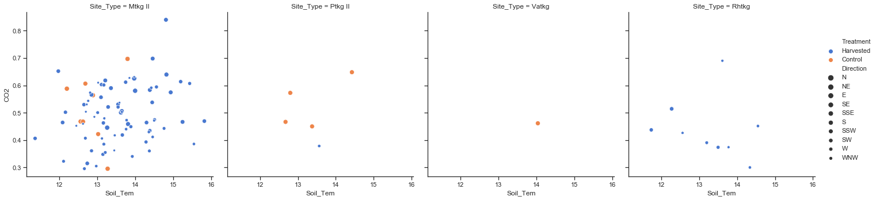

**Fig 10. CO2 distribution based on treatments (control, and harvested)**

In respect to Soil temperature (fig. 10), highest emission has been recorded in harvested site.

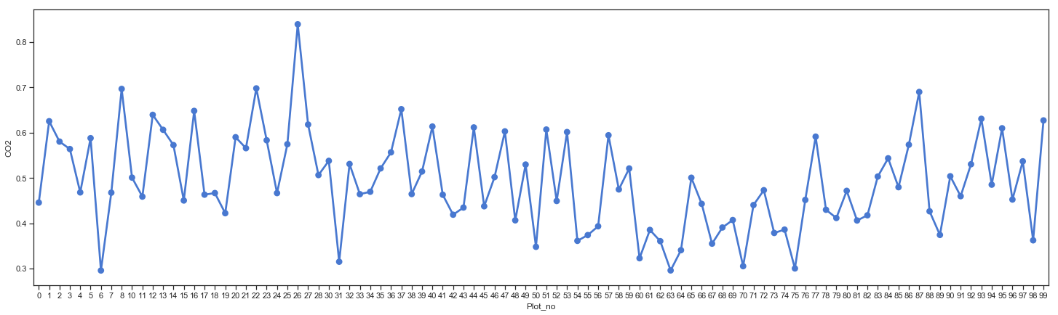

**Fig 11. Plot wise CO2 emission trend**

A fluctuated trend (fig 11) has been seen from plot wise emission distribution over the summer (June-August, 2017) period. At plot number 26, highest level of emission has been recorded.

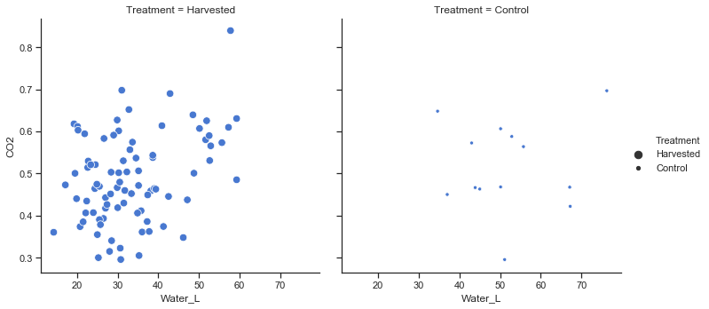

**Fig 12. A comparison between treatments**

From the figure 12, deepest water level has been found in control site while the highest emission is from harvested site.

# 2 Visualization through QlikView

In the part of visualization, we have analyzed and presented the Lettosuo data with QlikView. The outcomes are presented below -

**Carbon (CO2) Emission by Plot**

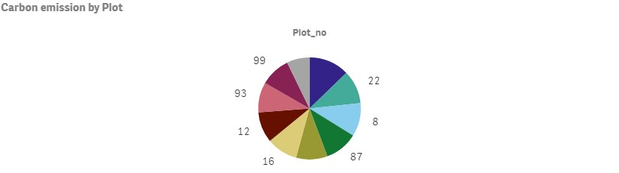

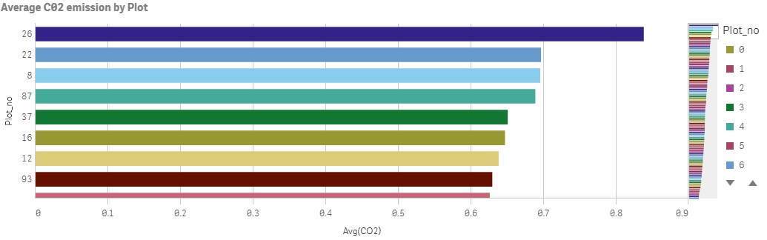

**Carbon (CO2) Emission by Date**

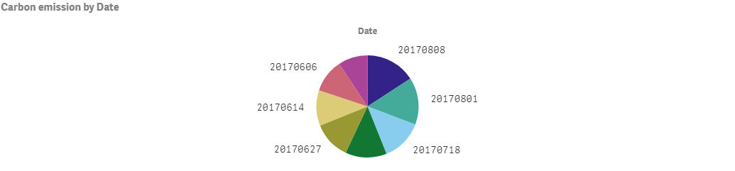

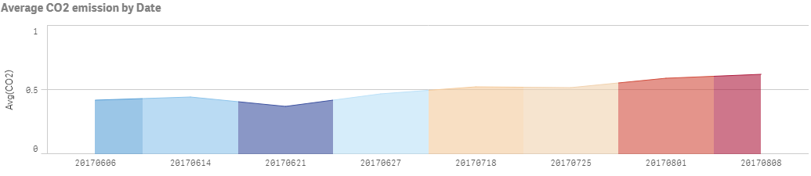

**Carbon (CO2) Emission by Date**

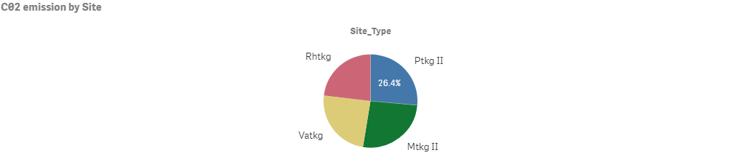

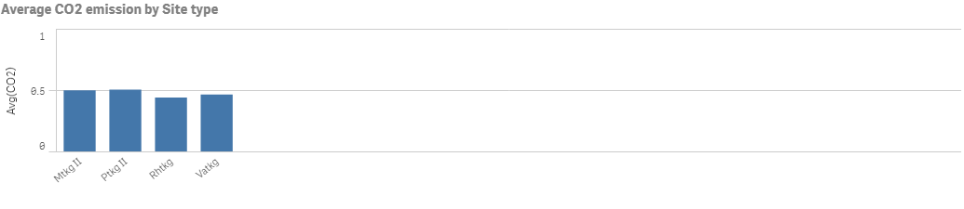

**Carbon (CO2) Emission by Direction**

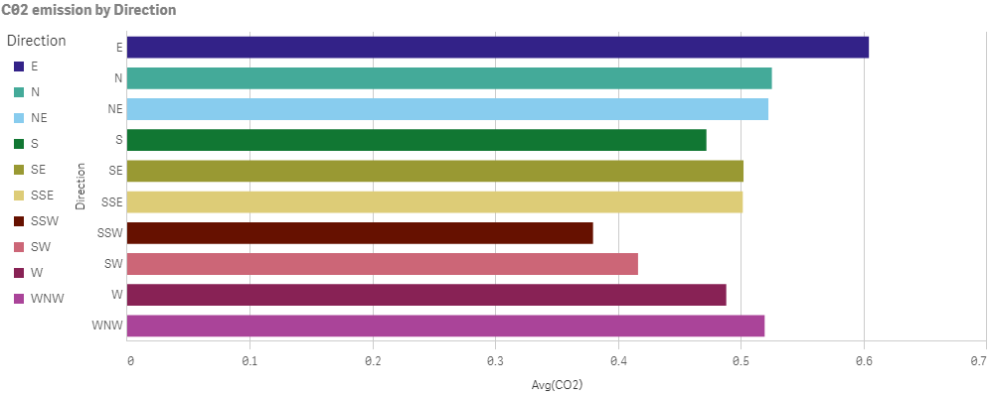

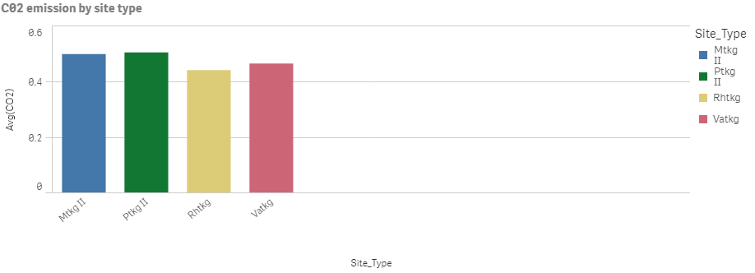

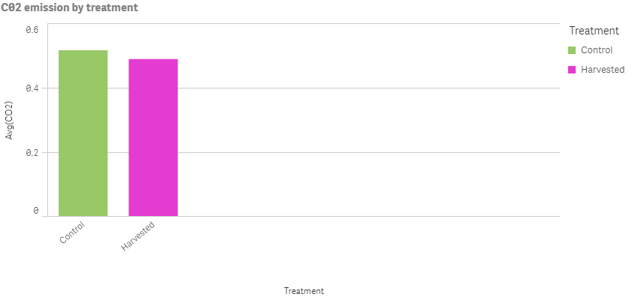

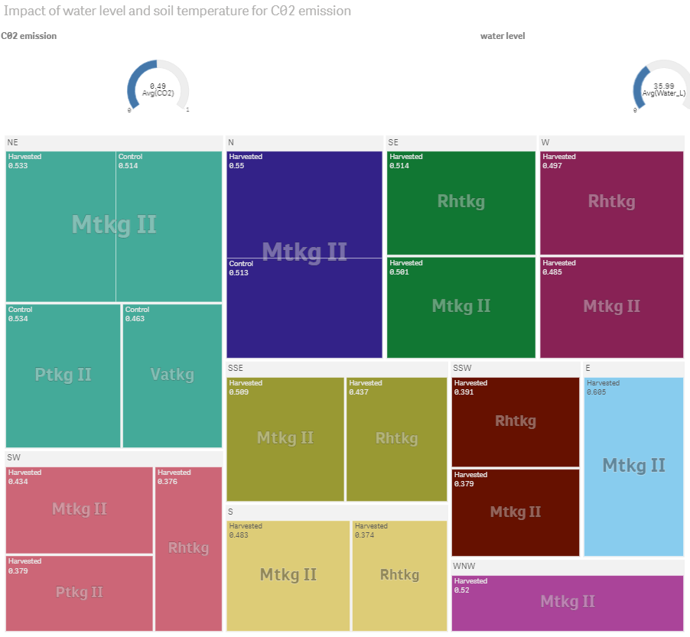

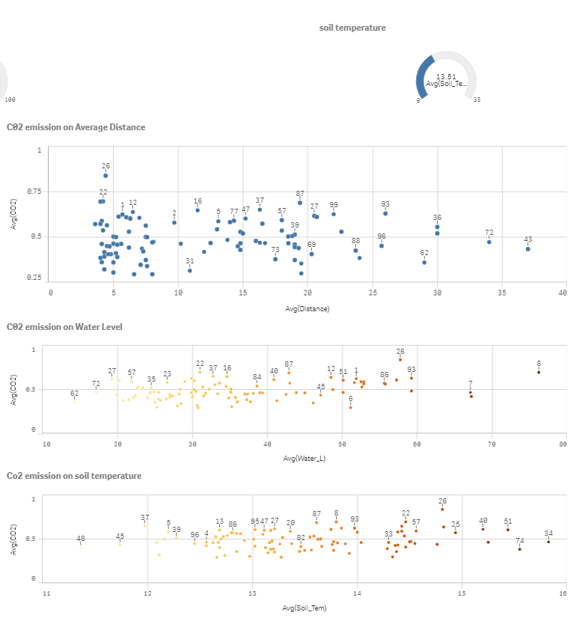

# 3 Conclusion

The analysis through Python and QlikView concluded that the highest emission of CO2 showed a trend over the period of time. The increasing rate of it was noticeable with the days of summer while the Soil temperature was increasing gradually. In a conclusion, the analysis placed a relationship between CO2 emission and Soil temperature which is also scientifically proved.